Balloon Popper

Using Python & Turtle

By Sunil Dangal

## Introduction

In this Balloon Popper project, I am going to create balloon, design it, implement it, and evaluate at last. To define the criteria for our project, we have:

1. **Keyboard Input Detection**

I am going to use keyboard input to increase the size of balloon and pop it.

1. **Multiple Inputs**

I am going to take multiple inputs to inflate it and when it reaches the condition it is inflated to much then it pops up.

1. **Using variables, conditions, and functions**

I am going to use variables, conditions, and function to inflate the balloon as we did in our previous project.

Firstly, the program needs detect the inputs for the balloon popper to increase its size and make it pop. Keyboard input needs to be registered to tell the computer to inflate it. And then, it requires multiple inputs to inflate the balloon. This program also needs to have a process of inflating the balloon by using conditions and when the balloon reaches the size that is required to pop the balloon. And at last, I am going to use variables, conditions, and functions to make this program work.

## Design

Now, this is a phase we find out what our design requirements look like. We are going to have Diagram, Flowchart, and pseudocode for the visual part.

**Diagram**

Now, we are going to have a green dot (circle), which will increase its size when user press the up-arrow key and when it reaches the certain point, it will then pop.

**Flowchart**

Below, is the flowchart for this project.

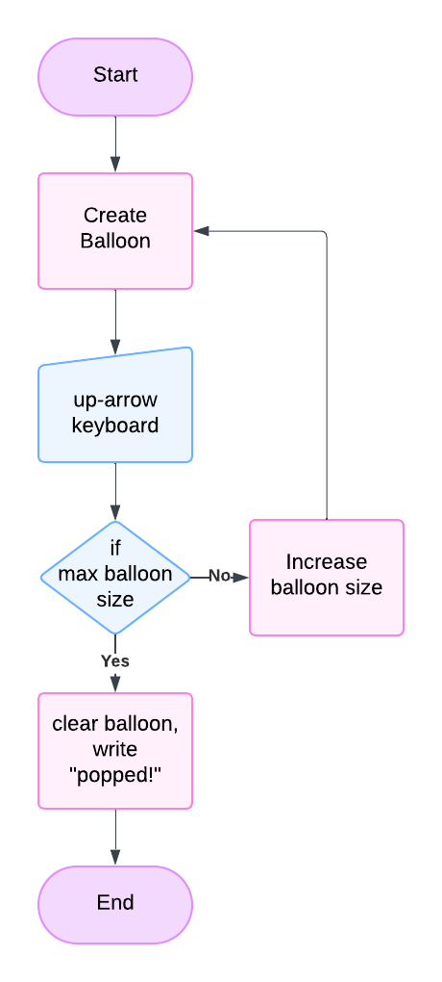

**Pseudocode**

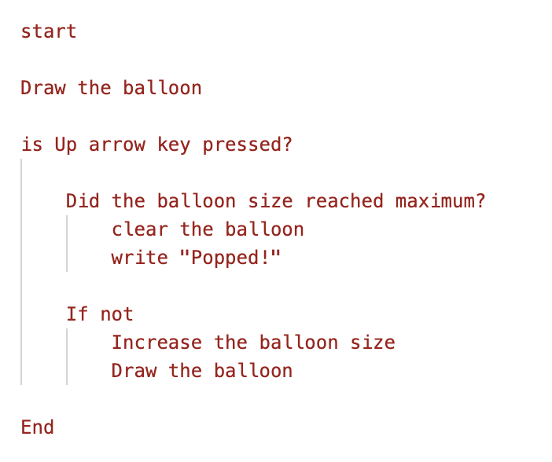

## Implementation

Check the code in balloon_popper.py file to see the code implementation.

## Features

We are going to add a feature where, when the balloon is inflated and popped then another balloon comes with different color like green, red and yellow. Also we are going to add deflate option, when down arrow key is pressed then the balloon will be deflated.

## Evaluate

Now, in this project, I was able to detect input from the keyboard making the balloon size bigger and smaller and pop using onkey commands by binding Up arrow key and down arrow key. We have used if statements to check the diameter of the balloon to a certain point to make it pop and again inflate it to use it again. We have used functions, 2 global variables’, conditions along with if statement to make this project success.